**Project Design Phase-II**

**Data Flow Diagram & User Stories**

|  |  |
| --- | --- |
| Date | 27 June 2025 |
| Team ID | LTVIP2025TMID34533 |
| Project Name | Pollen Profiling |
| Maximum Marks | 4 Marks |

**Data Flow Diagrams:**

A Data Flow Diagram (DFD) is a traditional visual representation of the information flows within a system. A neat and clear DFD can depict the right amount of the system requirement graphically. It shows how data enters and leaves the system, what changes the information, and where data is stored.

**Example:** [**(Simplified)**](https://developer.ibm.com/patterns/visualize-unstructured-text/)

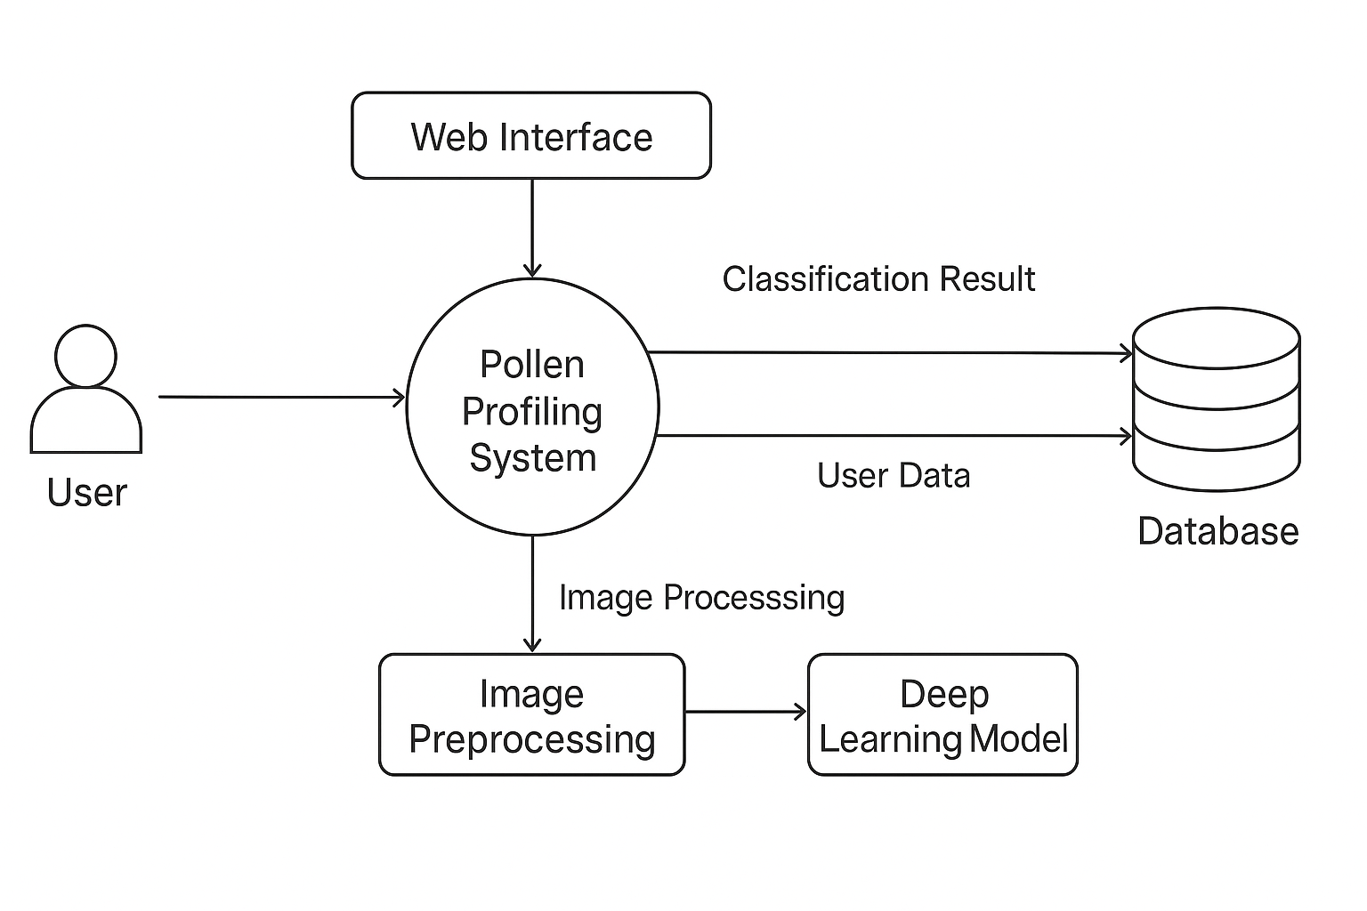

**User Stories**

Use the below template to create product backlog and sprint schedule

| **Sprint** | **Functional Requirement (Epic)** | **User Story Number** | **User Story / Task** | **Story Points** | **Priority** | **Team Members** |
| --- | --- | --- | --- | --- | --- | --- |
| Sprint-1 | Data Collection | USN-1 | As a data engineer, I can collect pollen image data for model training. | 2 | High | Balla Naga Mallika |
| Sprint-1 | Data Loading | USN-2 | As a developer, I can load and visualize the dataset in the pipeline. | 1 | Medium | Ch Gowtham Narendra |
| Sprint-1 | Data Preprocessing | USN-3 | As a developer, I can handle missing values and clean the data. | 3 | High | Cherukuri Manikanta |
| Sprint-1 | Data Preprocessing | USN-4 | As a developer, I can encode and manage categorical variables. | 2 | High | Ch Gowtham Narendra |
| Sprint-2 | Model Building | USN-5 | As an ML engineer, I can build and train the classification model | 5 | High | Balla Naga Mallika |
| Sprint-2 | Model Evaluation | USN-6 | As an ML engineer, I can test and validate the performance of the model | 3 | High | Cherukuri Manikanta |
| Sprint-2 | UI Development | USN-7 | As a front-end developer, I can design working HTML pages for deployment | 3 | Medium | Amaresam Ramanjaneyulu |
| Sprint-2 | Deployment | USN-8 | As a back-end developer, I can deploy the trained model using React. | 5 | High | Amaresam Ramanjaneyulu |